Agile Methodology

# What is Agile Methodology?

Agile is a software development approach that promotes incremental delivery, team collaboration, continuous planning, and flexible response to change. Unlike traditional (Waterfall) models, Agile allows for frequent reassessment of project direction.  
  
“Agile is not a process; it's a mindset focused on delivering value quickly and efficiently.”

# Key Principles of Agile

According to the Agile Manifesto:

1. Individuals and interactions over processes and tools

2. Working software over comprehensive documentation

3. Customer collaboration over contract negotiation

4. Responding to change over following a plan

[Insert image: Agile Manifesto principles in 2x2 quadrant layout]

# Agile vs Waterfall: A Comparison

|  |  |  |
| --- | --- | --- |
| Feature | Agile | Waterfall |
| Approach | Iterative & Incremental | Linear & Sequential |
| Flexibility | High (adaptive to change) | Low (rigid plan) |
| Testing | Continuous | At end of development |
| Feedback | Frequent | After completion |
| Collaboration | High with stakeholders | Minimal |

# Agile vs Waterfall: What is the Difference? Which is Right ...

# Agile Lifecycle (Phases)

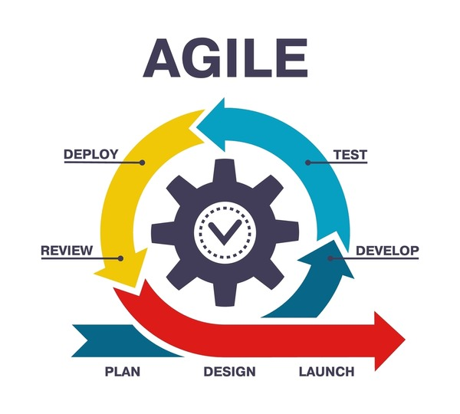

1. Concept/Initiation  
2. Iteration/Increment Planning  
3. Design & Development  
4. Testing  
5. Release  
6. Feedback & Review

# Agile Frameworks and Methodologies

## 1. Scrum

Most widely used Agile framework  
- Based on roles: Product Owner, Scrum Master, and Development Team  
- Uses Sprints (2–4 week iterations)  
- Events: Daily Scrum, Sprint Planning, Sprint Review, and Retrospective

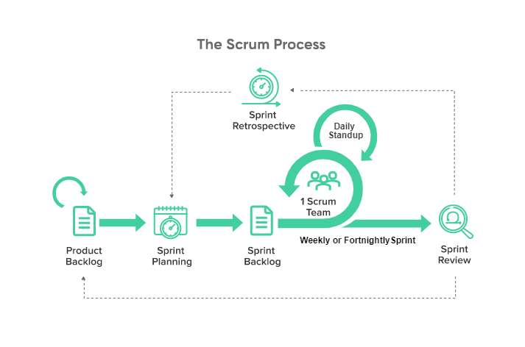

## 2. Kanban

Visual workflow management method  
- Uses a Kanban board to represent tasks in columns like To Do → In Progress → Done  
- Focuses on work-in-progress limits

## Kanban: Definition, Method, Principles, Examples & Kanban Board

## 3. Extreme Programming (XP)

Focuses on technical practices  
- Practices include: Test-Driven Development, Pair Programming, and Continuous Integration

# Benefits of Agile

- Faster Time to Market  
- Better Product Quality  
- Enhanced Customer Satisfaction  
- Improved Team Collaboration  
- Adaptability to Changing Requirements

# Conclusion

Agile methodology empowers teams to deliver value early and often, while continuously improving processes based on feedback. It supports a people-first, adaptive approach to software development that aligns with dynamic business needs.